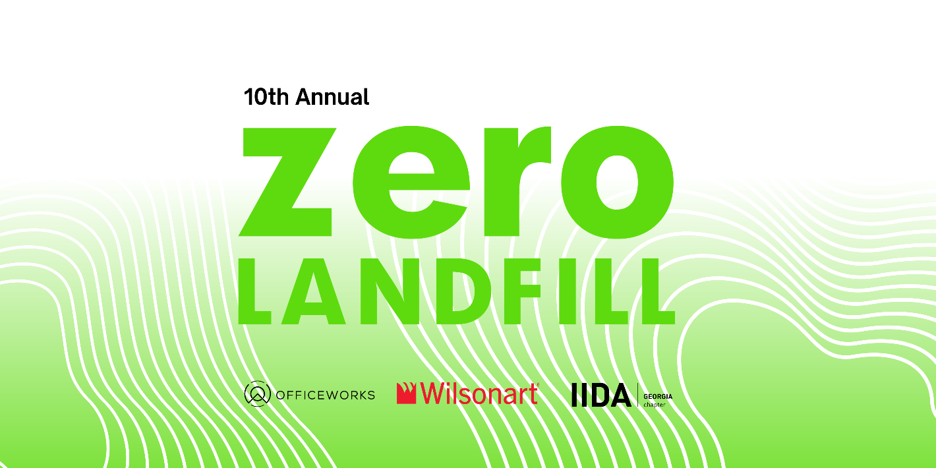

In the design and construction industry, we find ourselves creating a lot of waste from materials collected in our finish libraries that inevitably make their way to the landfill.
So we asked, why not find a way to repurpose or upcycle, these materials back into our community? Once unwanted materials can now be a free-source materials for educators and non-profit associations, or be transformed into works of art by artists and crafters.

IIDA Georgia (International Interior Design Association of Georgia) is hosting the 10th annual ZeroLandfill Atlanta event with Wilsonart. To date, we have helped upcycle more than 399,000 pounds of discontinued architectural and interior design samples. Help us beat our previous year totals by participating in the 2023 ZeroLandfill Atlanta event!

Picking up Materials? We welcome all educators, crafters, hobbyists, artists, students and the general public to join us on Saturday, August 12th at Officeworks, from 8:00 AM until 1:00 PM. Items are FREE and are on a first come, first serve basis! We recommend showing up earlier rather than later. Register under “Tickets- Shopper” on our Eventbrite page. Feel free to bring your own items to "shop" with, such as wagons, buggies, carts, etc. Please help us to share the word!

Officeworks
1811 Marietta Blvd NW,
Atlanta, GA 30318

Please RSVP via this Eventbrite link:
https://www.eventbrite.com/e/zerolandfill-atlanta-2023-tickets-664938046597

Volunteering? We need a lot of help on the drop off days (Wednesday and Friday) and the Saturday event. Register to volunteer and we will send additional information to you via email. For those in the design industry, each volunteer hour can be self-reported as (1) USGBC CE hour to help you maintain your LEED GA or AP credentials. You must be 18 years of age to volunteer:
Volunteer Sign-Up Link

A volunteer coordinator will reach out to you with more information closer to the dates. Please dress in comfortable clothing with sneakers or boots. We also suggest bringing a water bottle, sunglasses, sunscreen, and leaving any valuables at home.

Donating Materials? Donations a will be accepted on these days:
Wednesday, August 9th from 3:00-6:00pm
Friday, August 11th from 3:00-6:00pm

If you plan on dropping off enough items to fill a box truck or larger, please drop off only on Friday, the 11th. Schedule Drop-off via Eventbrite https://www.eventbrite.com/e/zerolandfill-atlanta-2023-tickets-664938046597

Questions? Contact us at ZeroLandfillATL@iidageorgia.org.

FREQUENTLY ASKED QUESTIONS
Is this stuff really free? Please take as much as your car will allow! Our goal is to have nothing left at the end of the event.

What can I expect to find? Carpet squares, resilient flooring planks, memo sized fabric and wallcovering, wood, decorative glass, resin, plastic laminate, paint decks, wood and metal samples.

How do I sign up? Please sign up via our Eventbrite pages. There is a separate link for volunteering.

What should I bring on Saturday? While we will have boxes from the items donated, they will get used quickly. We recommend bringing your own boxes, bags, wagons, carts etc. to collect your things. Volunteers are available to help you carry everything to your vehicle.

What should I wear? August in Georgia is hot. Please dress cooly and comfortably. Closed toed shoes are recommended, as this event takes place in a working warehouse.

Can I bring my kids on Friday? Please do not bring children if you are volunteering. We will be moving hundreds of pounds of materials and directing traffic. Volunteers must be 18 years of age or older.

Can I bring my kids on Saturday? You may bring your kids, but keep in mind this is a busy and active warehouse and children must be supervised at all times. ZeroLandfill and IIDA Georgia are not liable for any injury.

Is there a restroom on site? Yes

